Enclosure 1: Design Specification (DS)
Module Name
Measurement
Alarm Management
Data Storage
Dashboard
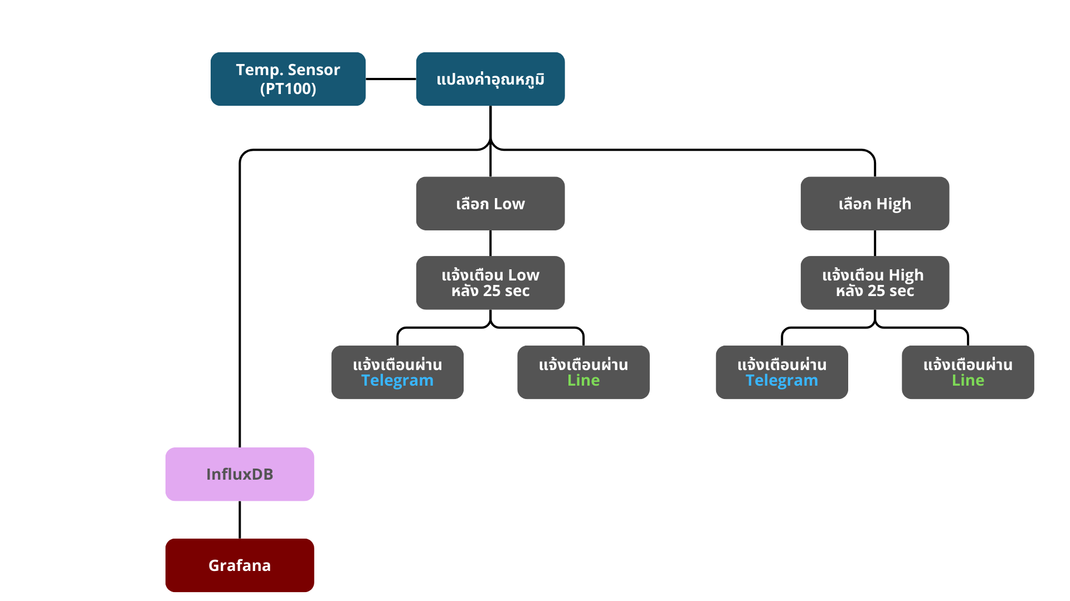
Process Flow

Dashboard (Grafana)

